Steps Involved for downloading Acadgild VM and Importing it to oracle VM

- Click on the link for downloading acadgild vm from your google drive.
https://drive.google.com/file/d/0Bxr27gVaXO5sZi1XTkhkLUUxUmc/view

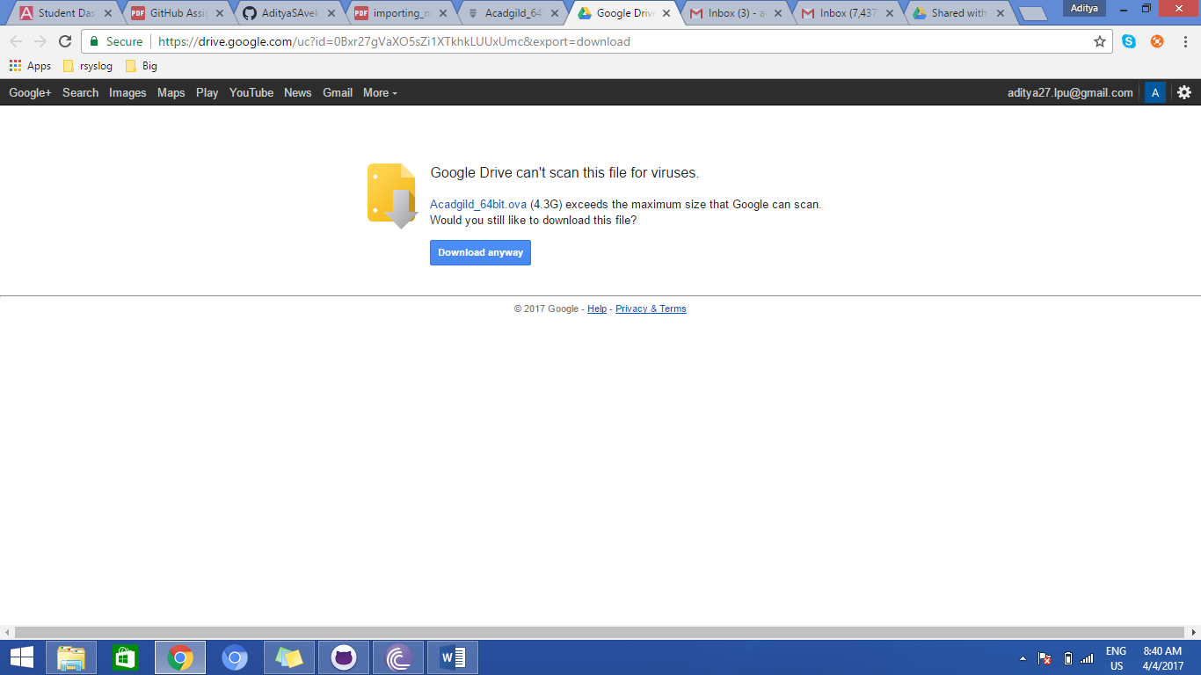

- Import the acadgild VM with .ova extention which you downloaded from the above link

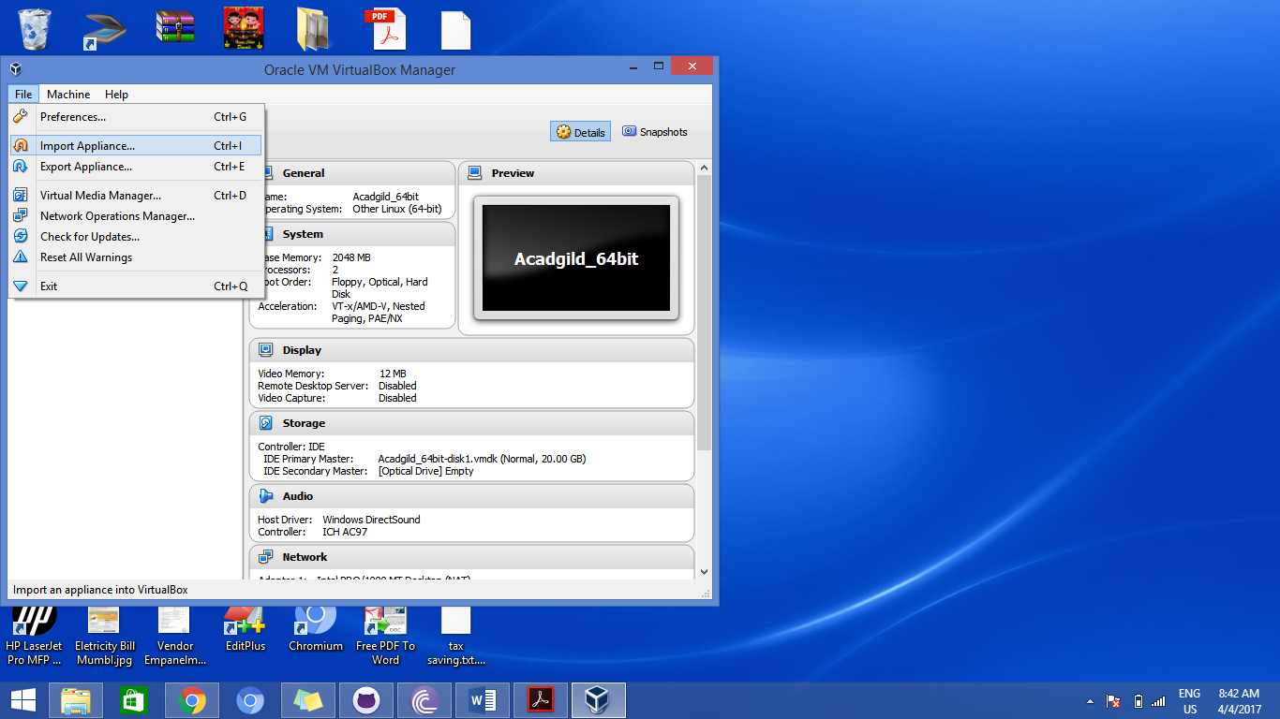

- Add the path of .ova file present on your system and click on Next.
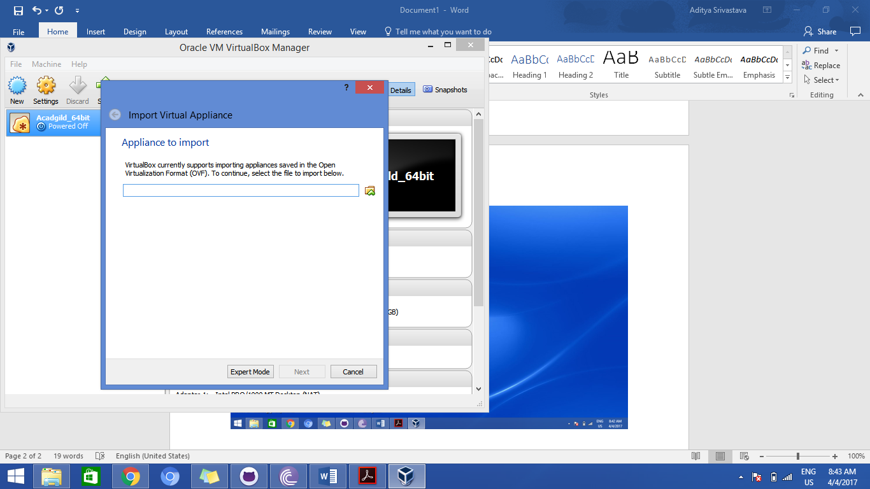
- Add the Application setting for the VM and click on import.

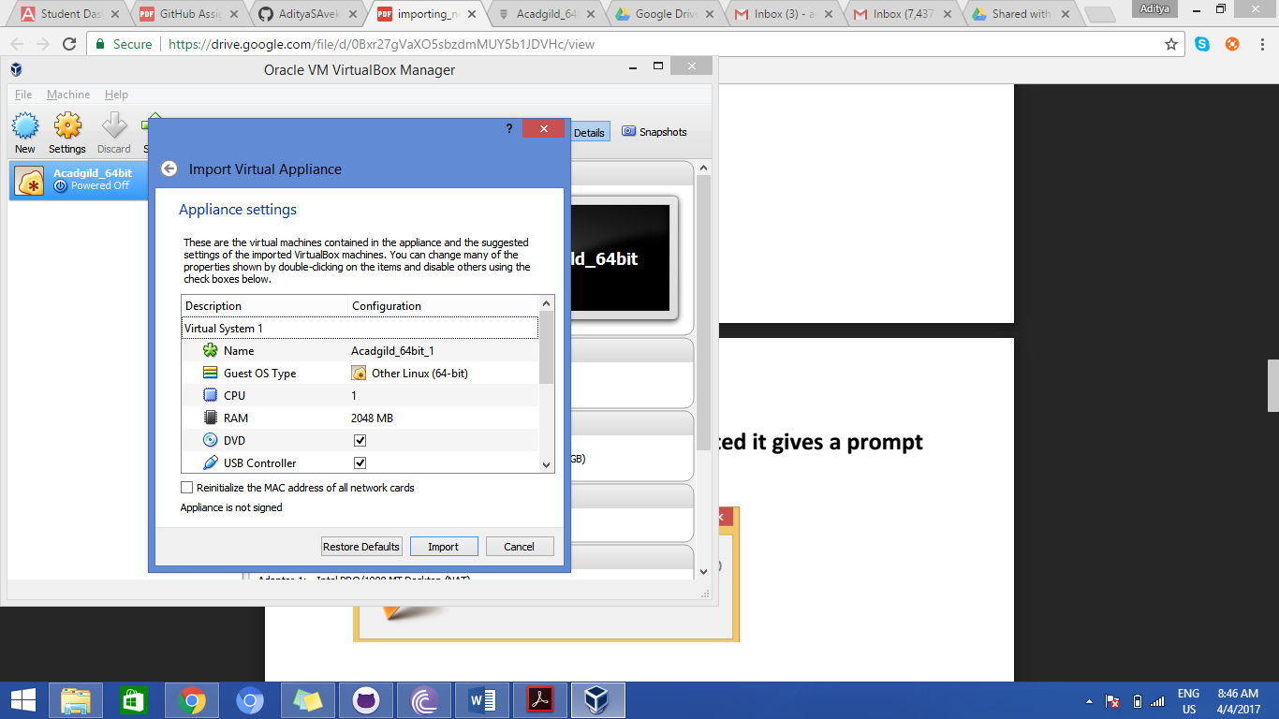

- Once all this is done, select your VM and click on start
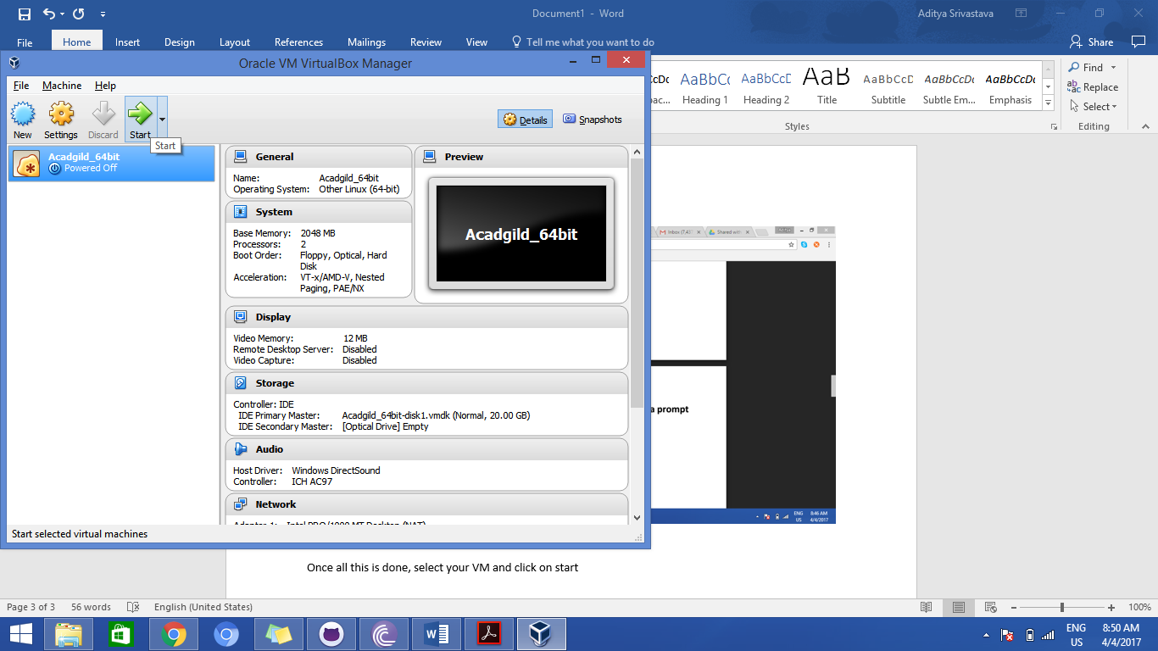
- You will see a username-acadgild
- Enter password- acadgild and you can start accessing your Virtual machine thereafter.

